**Lab4 Week1 & Week2 Report**

Names: Zixiao Wang, Yue Zhang

NetID: zw579, yz2455

Date: Nov 17, 2019

**Introduction:**

In lab4, we explored the PreemptRT kernel patch through following steps:

1. On the current system, we implemented a square wave signal in C and measured its performance.
2. Installed a new kernel patched with PreemptRT and compiled it.
3. On the new system, run the square wave to check installation and test performance of the real time system.

**Design and Test:**

Week 1

1. Performance measurement using cyclictest

* Download and install Cyclictest from Github:

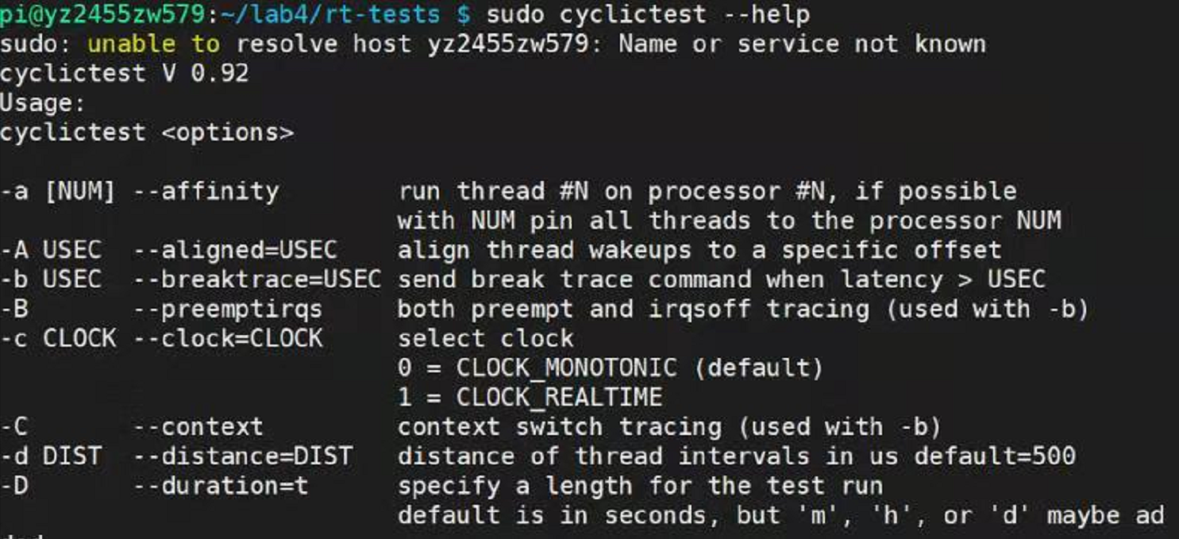

Fig1. Cyclictest installed

* Check the latency of system by running at threads at priority = 90, using nanosleep timer, locking memory for 10000 loops:

time sudo cyclictest -p 90 -n –m -t4 -l 10000

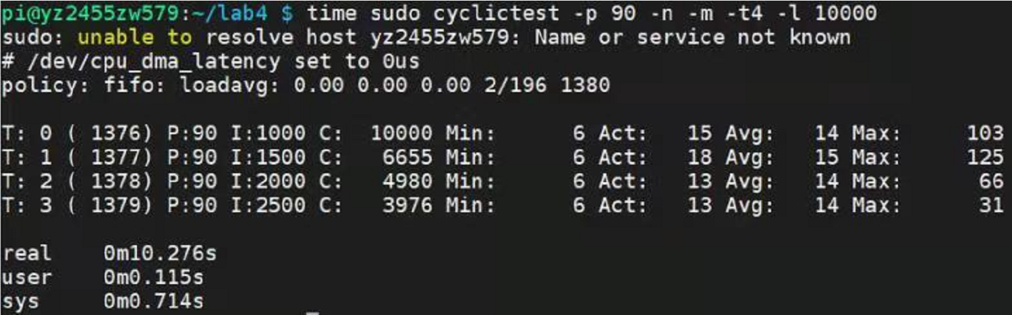

Fig2. 10000 loops unloaded

* Increase number of loops by 300000, running:

time sudo cyclictest -p 90 -n –m -h 500 -t4 -l 300000

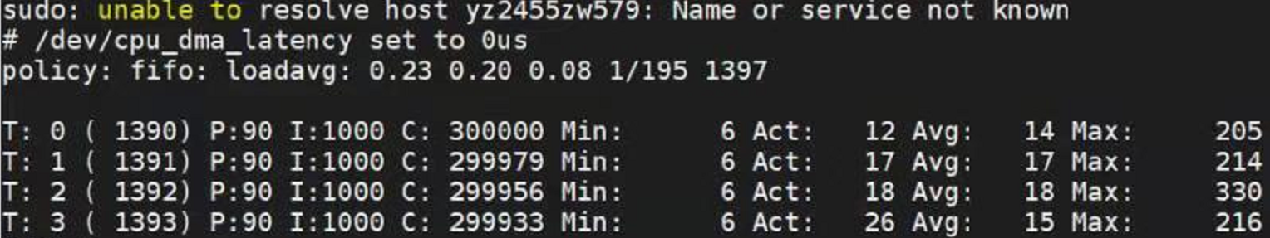

Fig3. 300000 loops unloaded

* Run 25 copies of sort_v1 in the background and repeat the command:

time sudo cyclictest -p 90 -n –m -h 500 -t4 -l 300000

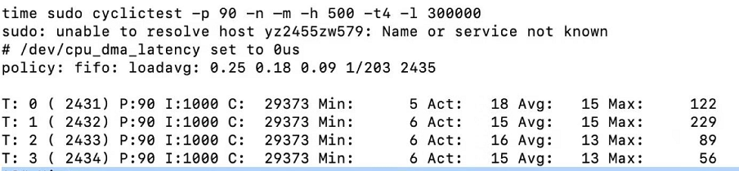

Fig4. 300000 loops loaded

- Use htop to make sure core is busy, CPU usage is 101%.

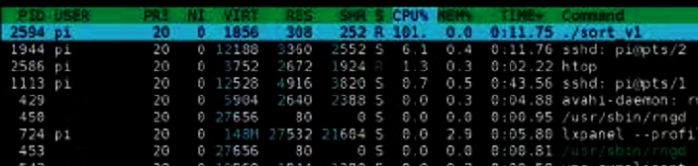

Fig5. Htop showing core busy

* Test performance of sort.c by running

sudo perf_4.9 stat ./sort_v1

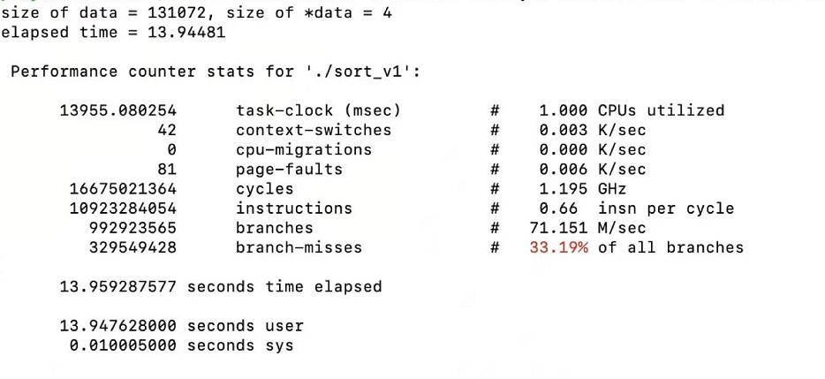

Fig6. Performance of sort_v1.c without quick sort

* Modify sort_v1,c to include a sort on a large array prior to entering loop, then test performance again.

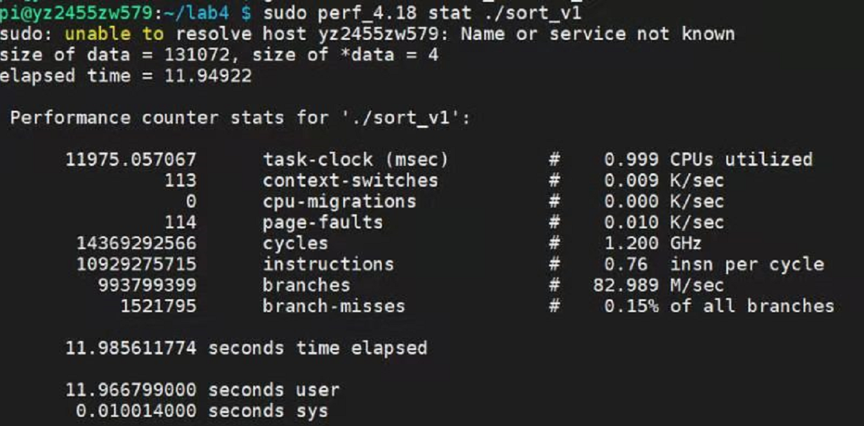

Fig7. Performance of sort_v1.c with quick sort

* Use blink.py and blink_v6.c to generate stable square wave and test their frequency upper bound when system is unload and loaded.
* Frequency upper bound for blink.py with unloaded system is 821Hz.

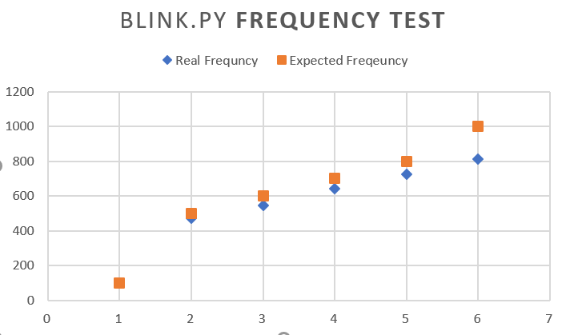

Fig8. Blink.py frequency test unloaded

* Frequency upper bound for blink.c with unloaded system is 50KHz.

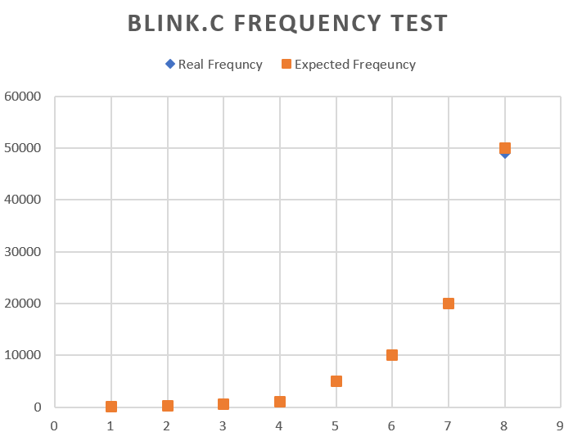

Fig9. Blink.c frequency test unloaded

* Frequency upper bound for blink.c with loaded system is 33KHz

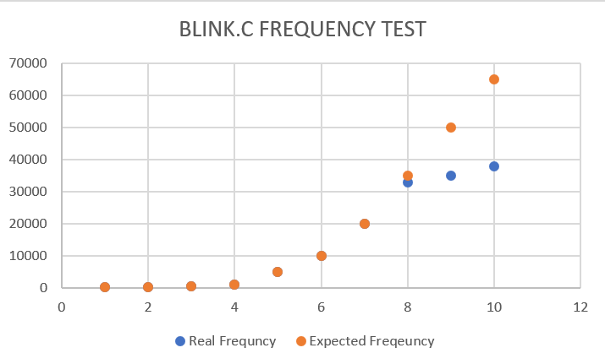

Fig10. Blink.c frequency test loaded

1. Build PreemptRT Kernel

* Free space on sd card:

Running df -h

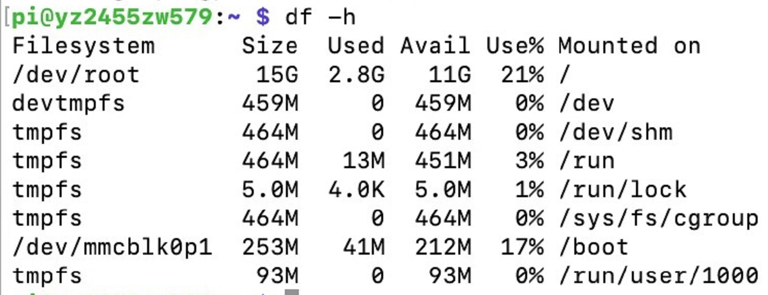

Fig11. 11G free space on sd card

Running dpkg --get-selections

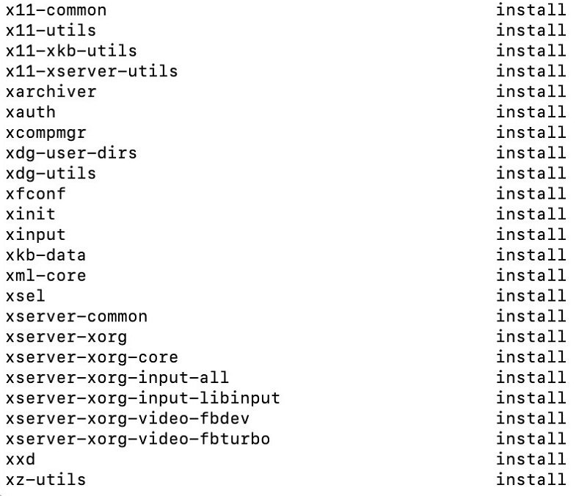

Fig12. All installed applications

Running du -sh *

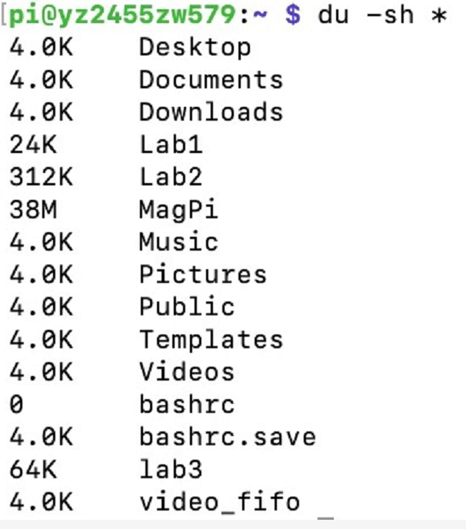

Fig13. Storage used in a particular directory

* Load appropriate source code for base Linux kernel:

git clone --single-branch --branch ‘rpi-4.14.y-rt’

After download, check free space

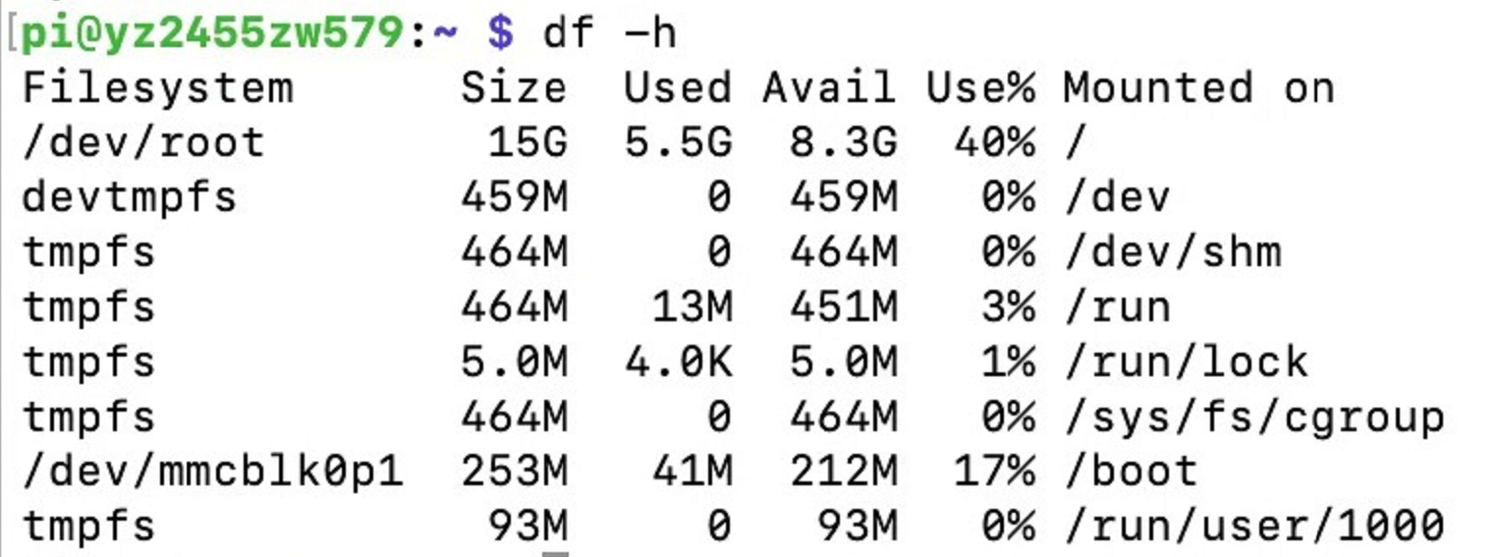

Fig 14. System free space

Check the version of code we have downloaded:

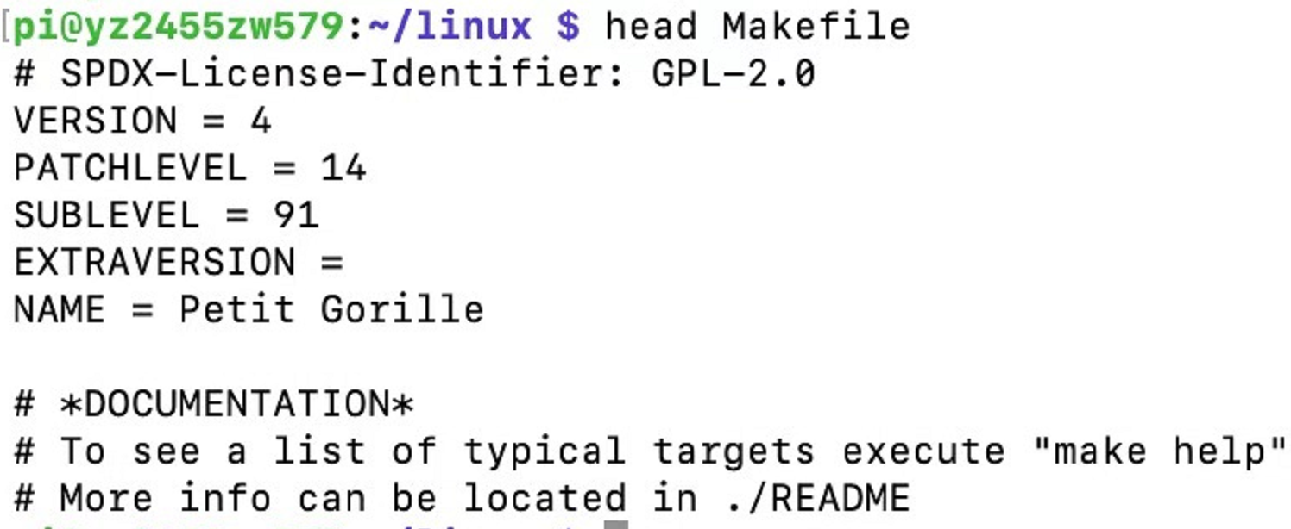

Fig15. Kernel Version

* Download PreemptRT Patch and merge with kernel source, by running:

user@host ~/linux$ wget <https://www.kernel.org/pub/linux/kernel/projects/rt/4.14/patch4.14.87-rt49.patch.gz>

* Then apply the patches to linux source:

zcat patch-4.14.87-rt49.patch.gz | patch -p1 > /home/pi/patch.log 2>&1

* Configure the kernel by installing libncurses5-dev and giving kernel image name kernel7. Then change settings in menuconfig.

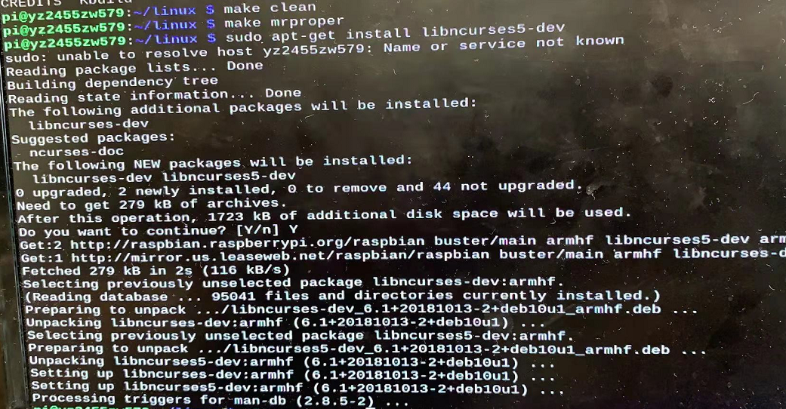



Fig16. Installing libncurses5-dev

* Compile the patched, configured kernel

Make.log shows no error when compiling.

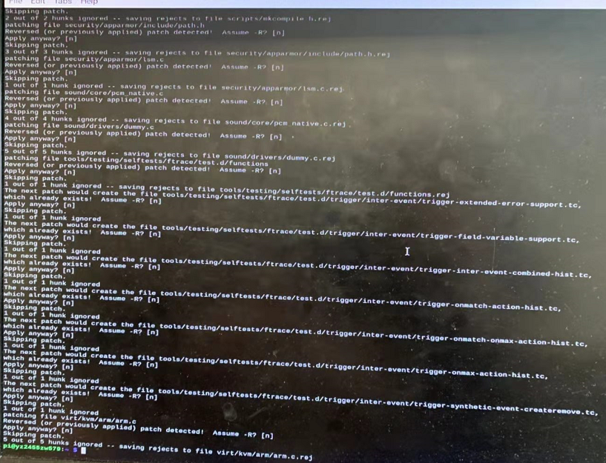

Fig17. Log information in another console

* Check free space then run

time make –j4 zImage modules dtbs > /home/pi/make.log 2>&1

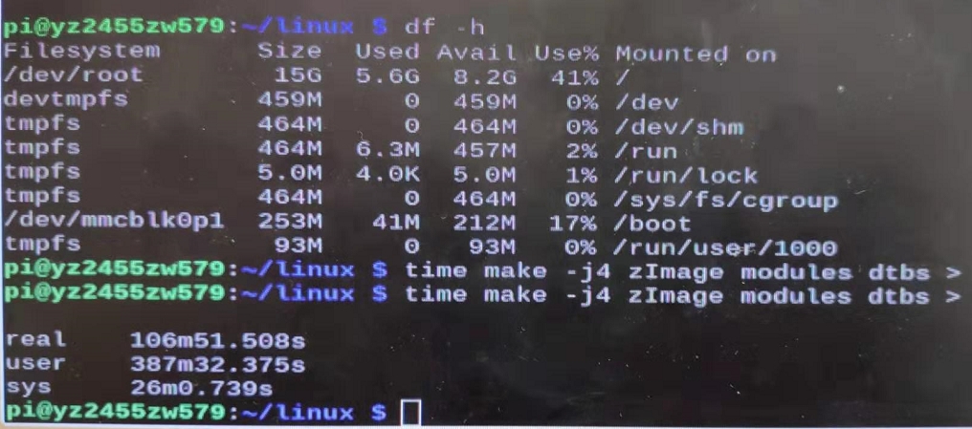

Fig18. Start 4 tasks which use 4 processors on RPi

Week 2

1. System Setup

* Place elements of new kernel in correct locations by running:

sudo cp arch/arm/boot/dts/*.dtb /boot/

sudo cp arch/arm/boot/dts/overlays/*.dtb* /boot/overlays/

sudo cp arch/arm/boot/dts/overlays/README /boot/overlays/

sudo scripts/mkknlimg arch/arm/boot/zImage /boot/$KERNEL.img

* Add the following to the end of the file /boot/cmdline.txt dwc_otg.fig_enable=0 dwc_otg.fig_fsm_enable=0 dwc_otg.nak_holdoff=0

And reboot the system.

1. Check performance of PreemptRT System

* First, try cyclic test with system unloaded:

sudo cyclictest -p 90 –m –n –t4 -l 10000

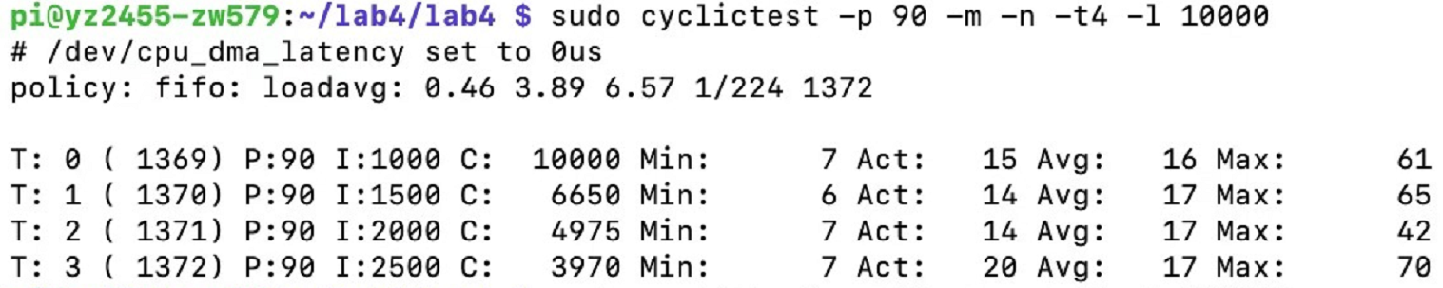

Fig19. Cyclictest 10000 loops unloaded

* Increase the number of loops

sudo cyclictest -p 90 -h 500 –m –n –t4 -l 300000

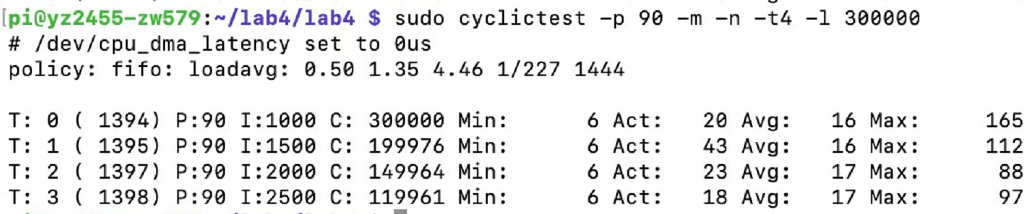

Fig20. Cyclictest 300000 loops unloaded

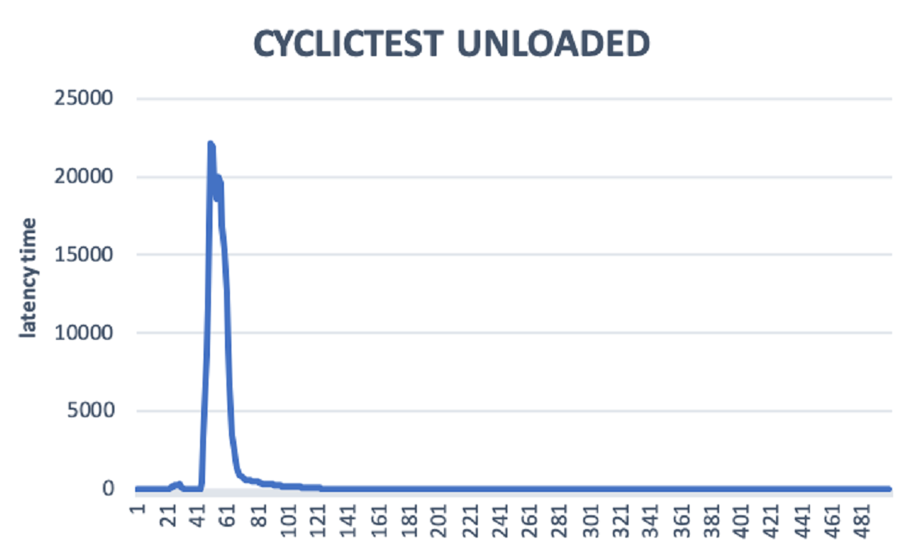

Fig20. Cyclictest 300000 loops histogram

* Try Cyclic test with system loaded:

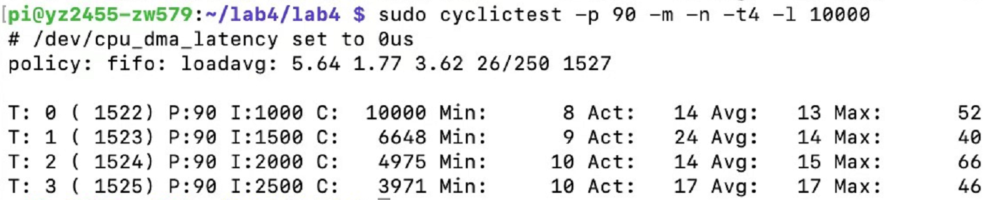

Fig21. Cyclictest 10000 loops loaded

* Increase the number of loops with system loaded:

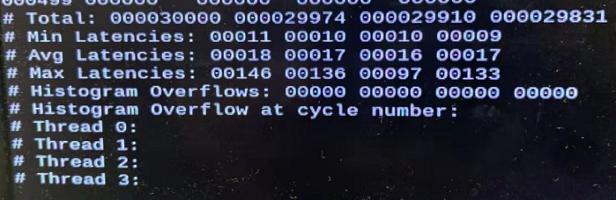

Fig22. Cyclictest 300000 loops loaded

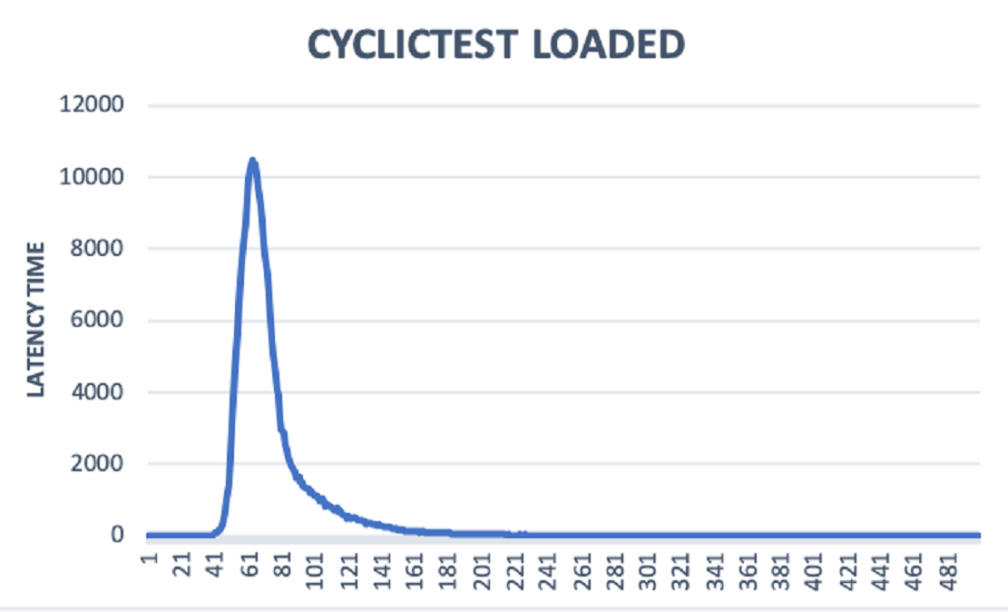

Fig23. Cyclictest 300000 loops histogram

* Re-run the perf tests on the two sort_v1 C codes

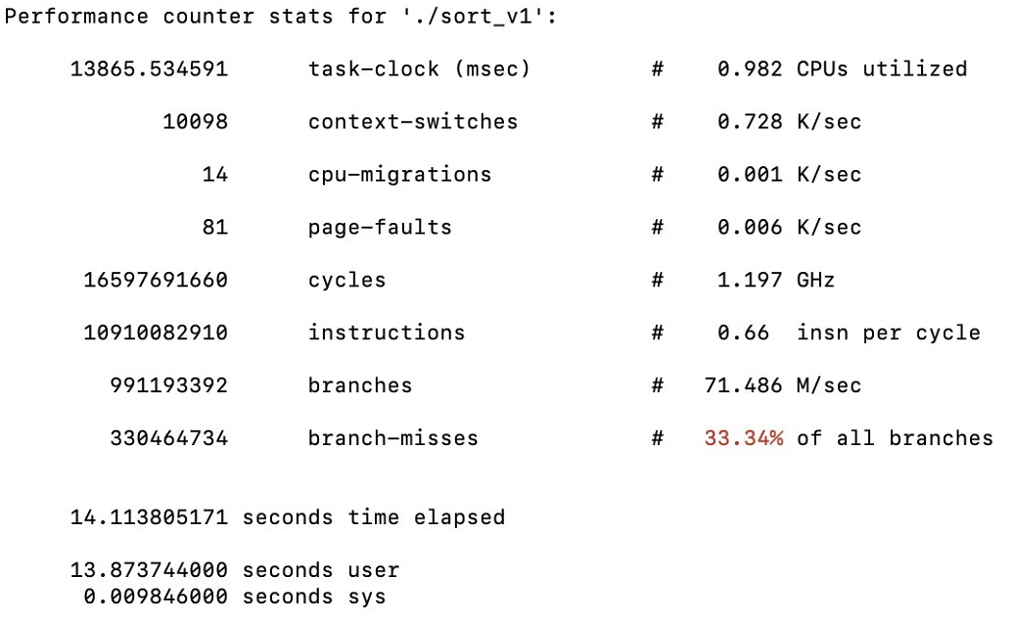

Fig24. Perf test on sort_v1.c with quick sort

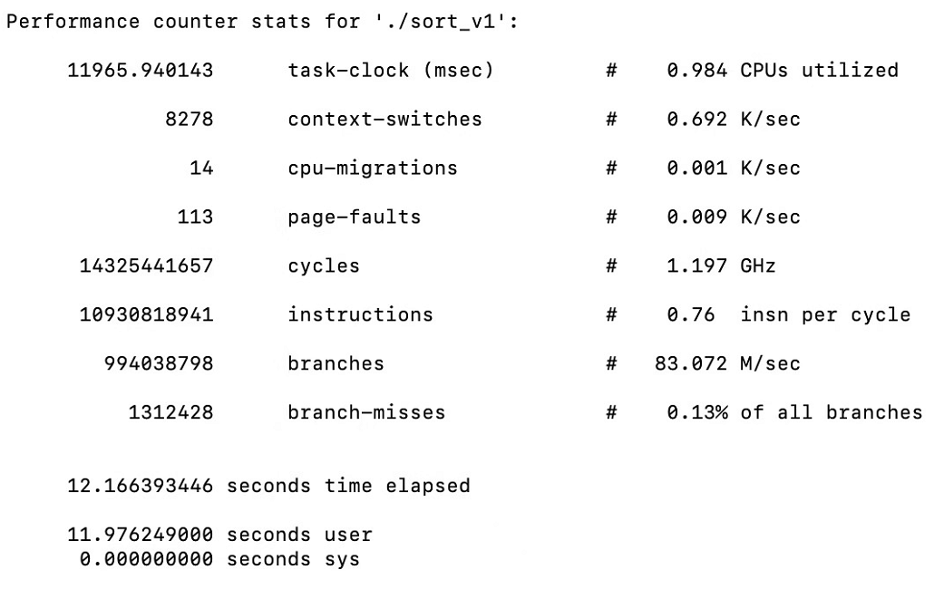

Fig25. Perf Test on sort_v1.c without quick sort

Note: **Comparing with perf test on original kernel, context-switches increase largely on PreemptRT Kernel.**

3. Square wave test

* Generate a stable square wave by modifying test_rt_skel_v7.c, checking it with the oscilloscope. Below are frequency test with system unloaded.

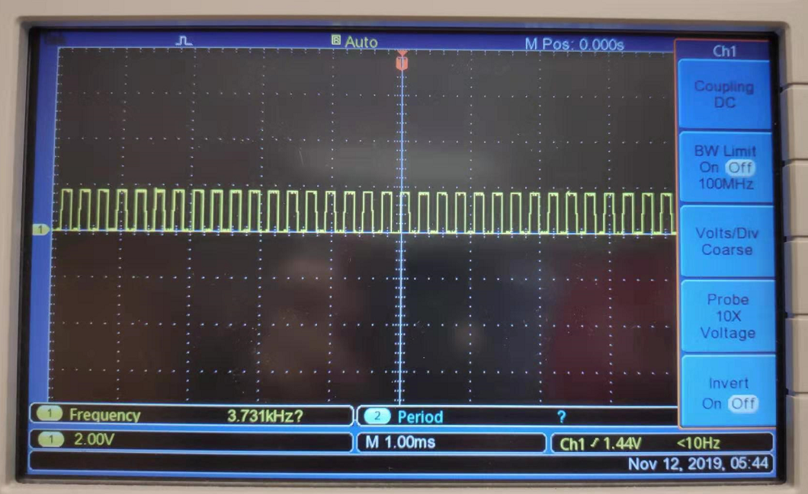

Fig26. interval=20000, frequency=3.73KHz

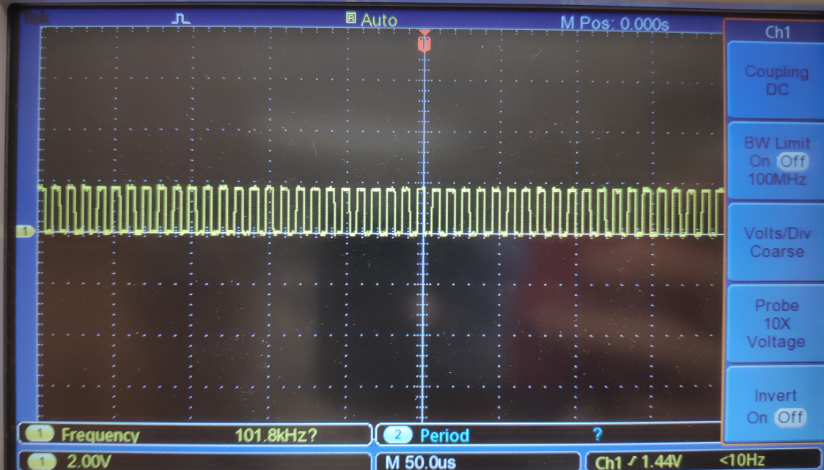

Fig27. interval=730, frequency=100Khz

* When system is loaded, frequency drops with same settings.

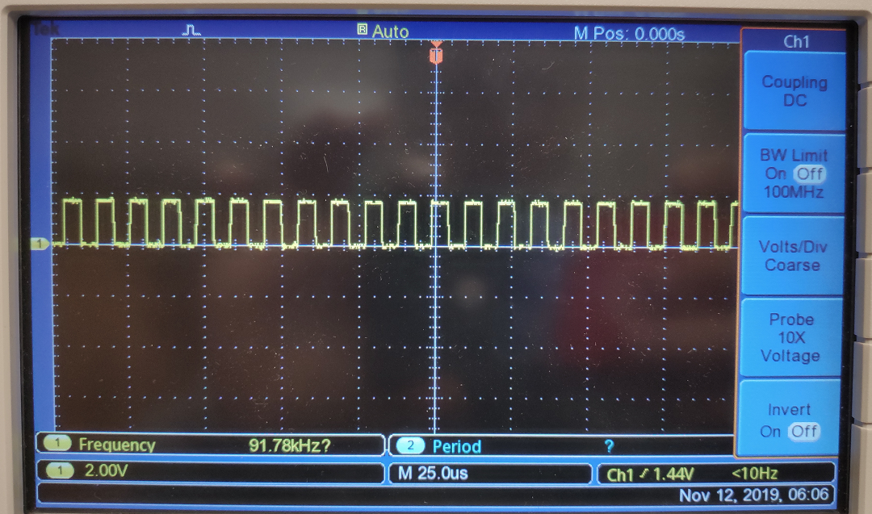

Fig28. interval=730, frequency= 91.78KHz, system loaded

* Run test_rt_v7 without any system loading and run ‘ps –alef | grep test_rt_v7’ and note the pid of the running test_rt_v7

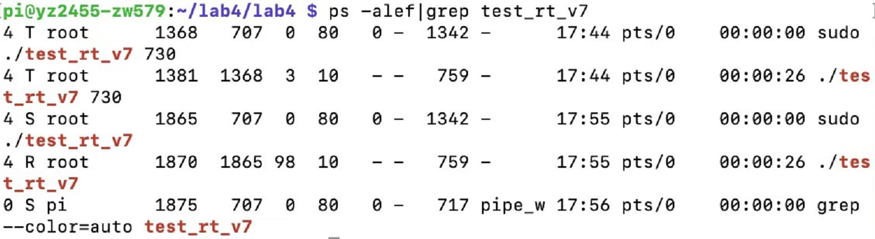

Fig29. Processes of test_rt_v7

* Run ‘chrt -p pid’:

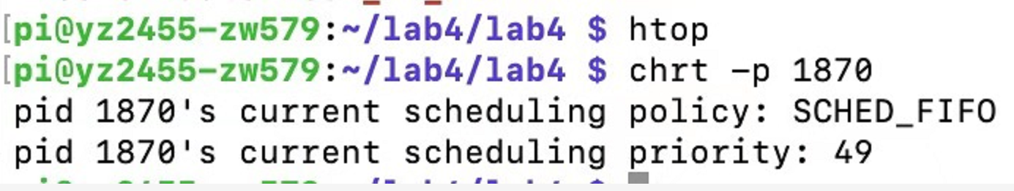

Fig30. Process priority

* Run test_rt_v7 730 with system loading and run ‘ps –alef | grep sort_v1’ and note the pid of the running loading test

Run ‘chrt -p pid’ as well

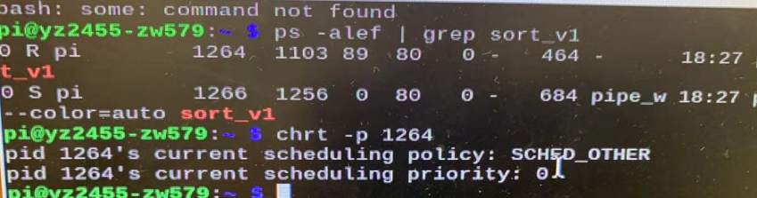

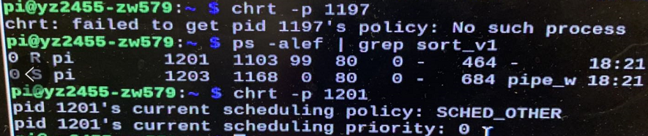

Fig31. Process and its priority

* Run ‘ps –alef | grep blink’ with system unloaded and note the pid of the running blink test

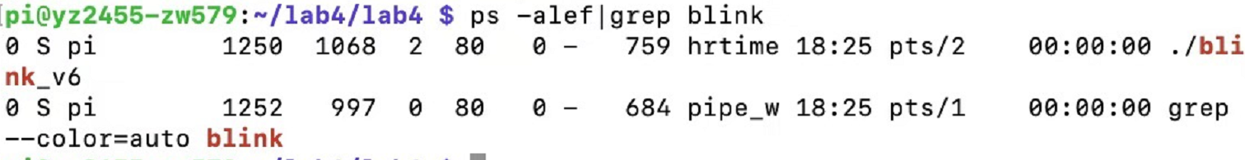

-Run ‘chrt –p pid’ where pid = pid of the blink test

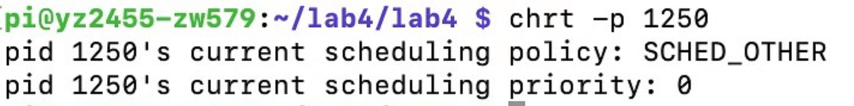

Fig32. Process and its priority

-Run ‘blink_v6’ to generate a stable square wave and add system loading.

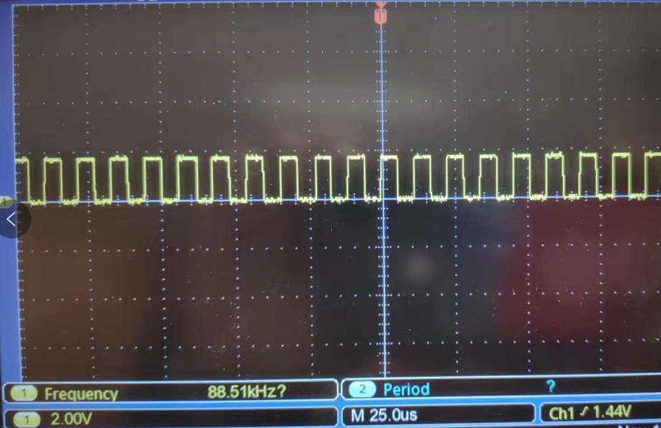

Fig33. Frequency dropping when loaded

System loading causes the frequency output dropping.

**Conclusions:**

Things worked well:

1. Download cyclitest from github and measure performance of current system. Check the latency of the current system for 10000 loops and 300000 loops in both unloaded and loaded conditions.
2. Measure performance of sort.c using perf.
3. Generate a stable square wave with blink.py and display the square wave in oscilloscope, increase the frequency and find the upper bound.
4. Installed wiringPi which will provide access to the GPIO pins in C.
5. Generate a stable square wave with blink_v6.c in unloaded condition and display the square wave in oscilloscope, increase the frequency and find the upper bound.
6. Generate a stable square wave with blink_v6.c in loaded condition and display the square wave in oscilloscope.
7. Free space on SD card to enable subsequent download and compilations.
8. Download linux source files.
9. Download the preemptRT patch and merge with kernel source.
10. Configure the kernel for the upcoming compilation.
11. Compile the patched, configured kernel.
12. Backup the SD card.
13. Use uname -a to confirm the updated kernel version.
14. Place elements of the new kernel in the correct locations.
15. Launch the newly compiled kernel.
16. Measure performance of the new system, similarly to the measurement of old system.
17. Check the latency of the new system for 10000 loops and 300000 loops in both unloaded and loaded conditions.
18. Measure performance of sort.c using perf.
19. Generate a stable square wave with test_rt_v7.c and check it with the oscilloscope.increase the frequency and found that there is no upper bound.
20. Explore features of the preempt-RT kernel.
21. Run test_rt_v7 without any system loading to generate a stable square wave.
22. Run test_rt_v7 730 with system loading(sort_v1 running 20 times) and check the wave. Compared with the unloading system, frequency of the output square wave is kind of fluctuating.
23. Same measurement on blink_v6 with system loading and unloading.

Some issues we met:

In the final square wave test, each time we load the system and then run test_rt_v7 730, the system got stuck.

Solution: control it using the keyboard and monitor connected to our Pi instead of using ssh.

**Improvement suggestion:**

Provide more study reference on kernel compilation.

**Things not clear enough:**

When we use cyclictest to measure the latency, we have saved the histogram into a chart in excel, but seems it has not been checked.